**computer science project**

Computer science(new)- 083



FITNESS CENTRE

NAME -ANSH TANWAR

CLASS-XII-C

RNO.-



CERTIFICATE

This is to certify that the COMPUTER SCIENCE project on “GOAL PLANNER” has been successfully completed by Ansh Tanwar of class XII-C in partial fulfilment of curriculum of CENTRAL BOARD OF SECONDARY EDUCATION (CBSE) of Computer Science(new)(083) leading to the award of AISSCE Practical Examination 2020-21

Board Roll No:-___________

Internal examiner external examiner principal

----------------------- ---------------------- --------------------

Acknowledgment

I extend my deep sense of gratitude and sincere thanks to our subject teacher Mrs. Anjali Rawlley for her valuable support and guidance in carrying my project work .

I also express my gratitude to all the faculty members, parents and my fellow mates who have helped me to carry out this work.

PREFACE

(Introduction to project)

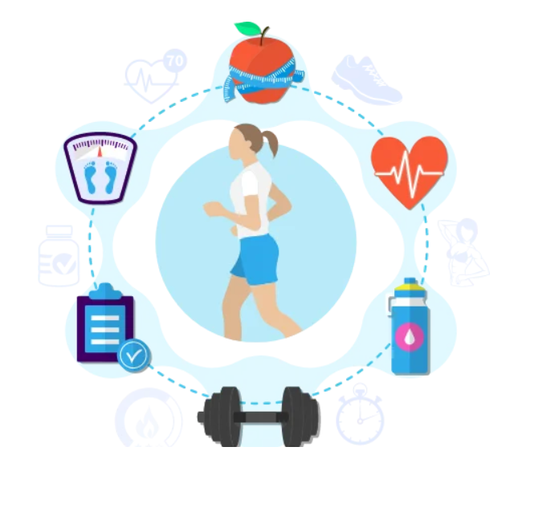

**This software is specially used to maintain any fitness centre where they can maintain records of any gym.To keep pace with time, to bring about the best result without malfunctioning and greater efficiency One has to use the data management software. Software has been an ascent in various organisations. Many software products working are now in markets, which have helped in making the organizations work easier and efficiently. Now only this software has to be loaded on the computer and work can be done.This prevents a lot of time and money. The work becomes fully automated and any information regarding the organization can be obtained by clicking the button. Moreover,**



**This software would:**

* Provide a complete package for fitness centre management
* Provide a smart body type test that would provide personalized recommendations and which program suites them best
* Have a complete information of fitness plans and diets available in the centre
* Give user information about price, offers and discounts and provide a bill for the things purchased

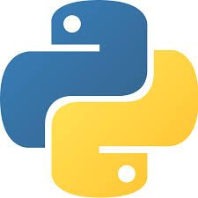

Introduction to

* Python is an [interpreted](https://en.wikipedia.org/wiki/Interpreted_language), [high-level](https://en.wikipedia.org/wiki/High-level_programming_language), general programming  [programming language](https://en.wikipedia.org/wiki/Programming_language" \o "Programming language). Created by [Guido van Rossum](https://en.wikipedia.org/wiki/Guido_van_Rossum) and first released in
* Python is [dynamically typed](https://en.wikipedia.org/wiki/Dynamic_programming_language) and [garbage-collected](https://en.wikipedia.org/wiki/Garbage_collection_(computer_science)). It supports multiple [programming paradigms](https://en.wikipedia.org/wiki/Programming_paradigms)
* . Python is often described as a "batteries included" language due to its comprehensive [standard library](https://en.wikipedia.org/wiki/Standard_library)
* Python was conceived in the late 1980s as a successor to the [ABC language](https://en.wikipedia.org/wiki/ABC_(programming_language)). Python 2.0, released in 2000, introduced features like [list comprehensions](https://en.wikipedia.org/wiki/List_comprehension) and a garbage collection system with [reference counting](https://en.wikipedia.org/wiki/Reference_counting).
* Python 3.0, released in 2008, was a major revision of the language that is not completely [backward-compatible](https://en.wikipedia.org/wiki/Backward_compatibility)
* Python [interpreters](https://en.wikipedia.org/wiki/Interpreter_(computing)) are available for many [operating systems](https://en.wikipedia.org/wiki/Operating_system). A global community of programmers develops and maintains [CPython](https://en.wikipedia.org/wiki/CPython" \o "CPython), an [open source](https://en.wikipedia.org/wiki/Open-source_software)[[34]](https://en.wikipedia.org/wiki/Python_%28programming_language%29#cite_note-34) [reference implementation](https://en.wikipedia.org/wiki/Reference_implementation). A [non-profit organization](https://en.wikipedia.org/wiki/Nonprofit_organization), the [Python Software Foundation](https://en.wikipedia.org/wiki/Python_Software_Foundation), manages and directs resources for Python and [CPython](https://en.wikipedia.org/wiki/CPython" \o "CPython) development.

coding

-------------------------------------------------------------

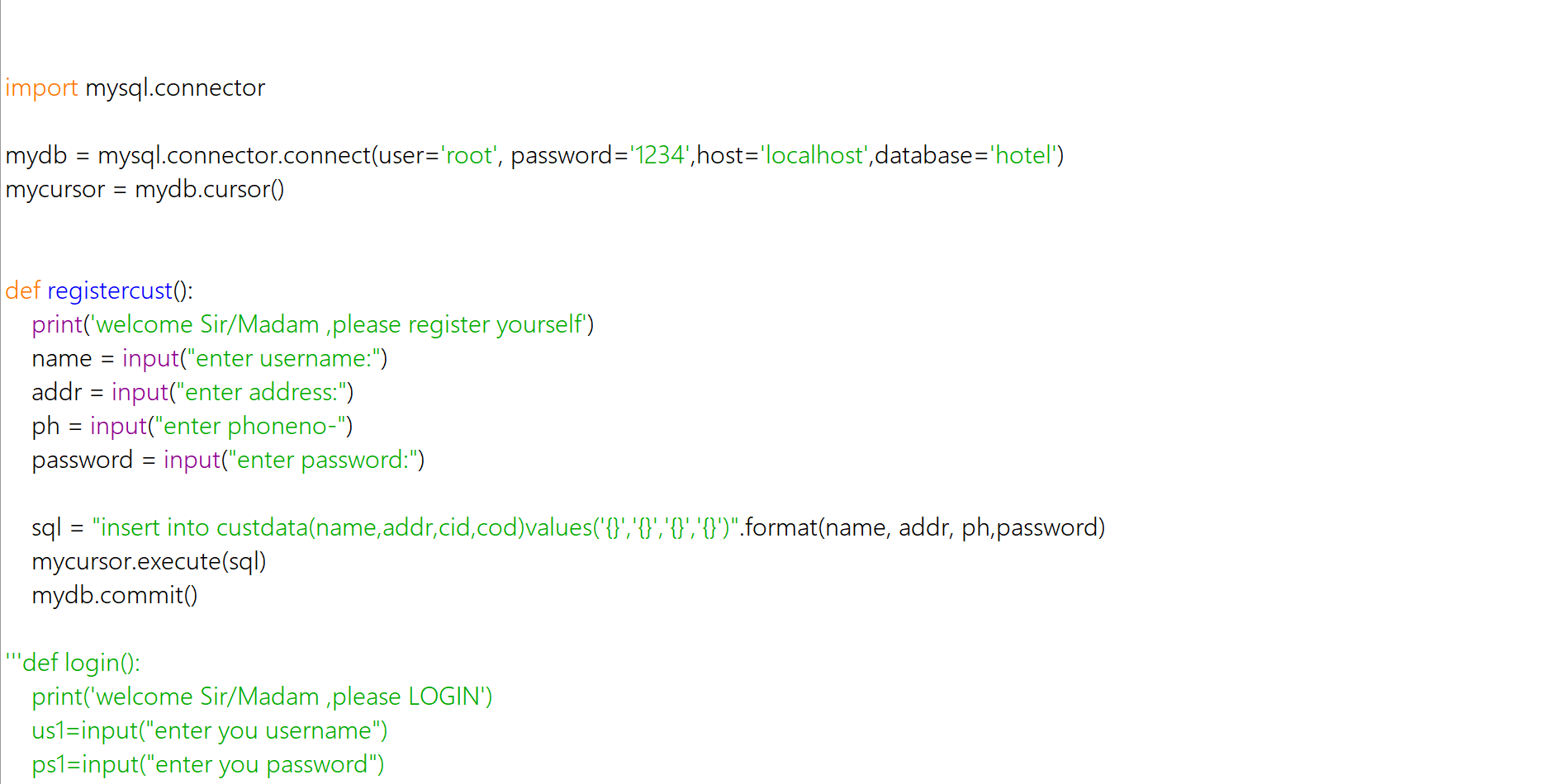

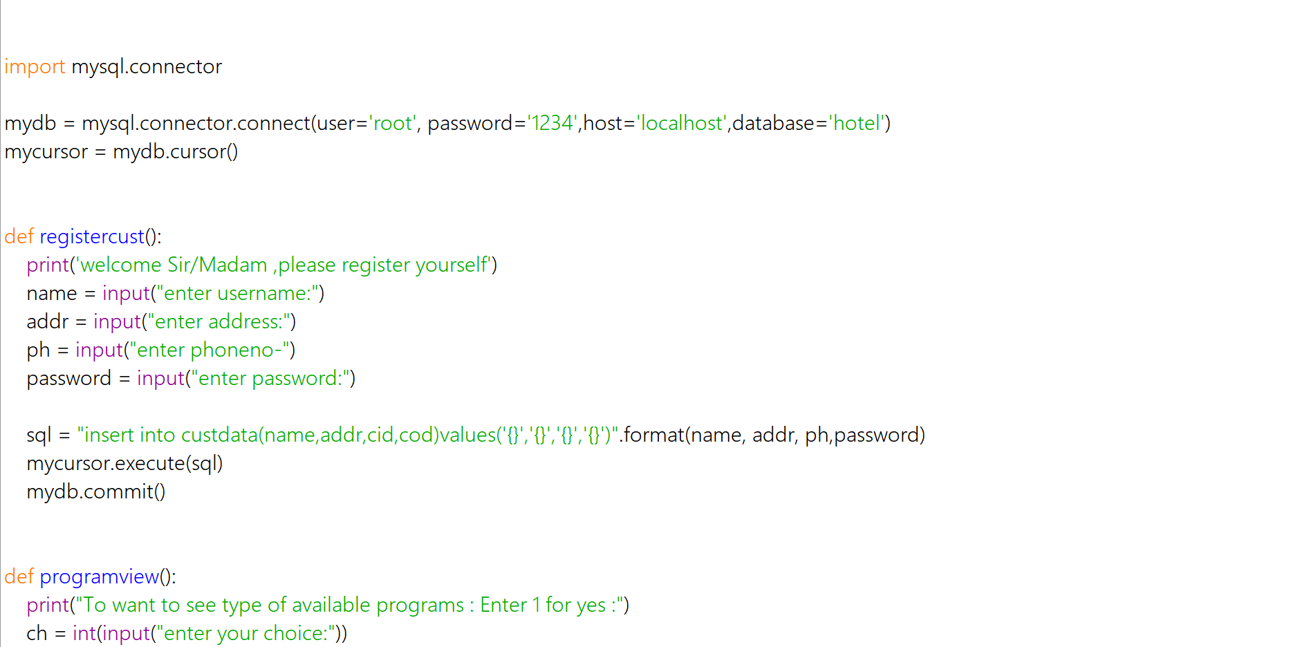

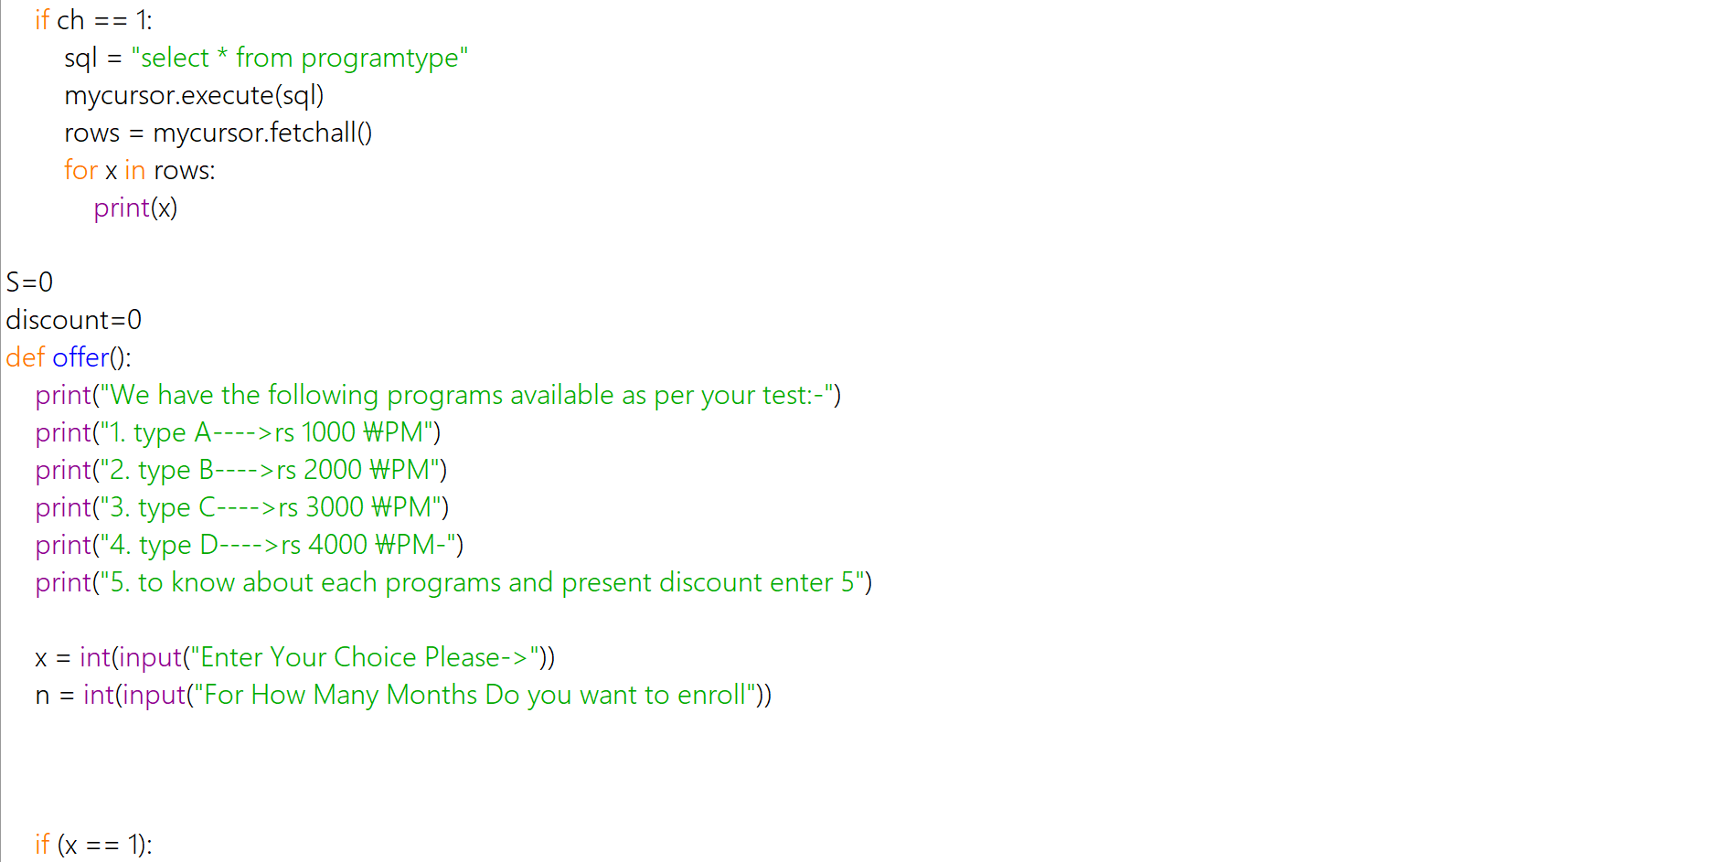

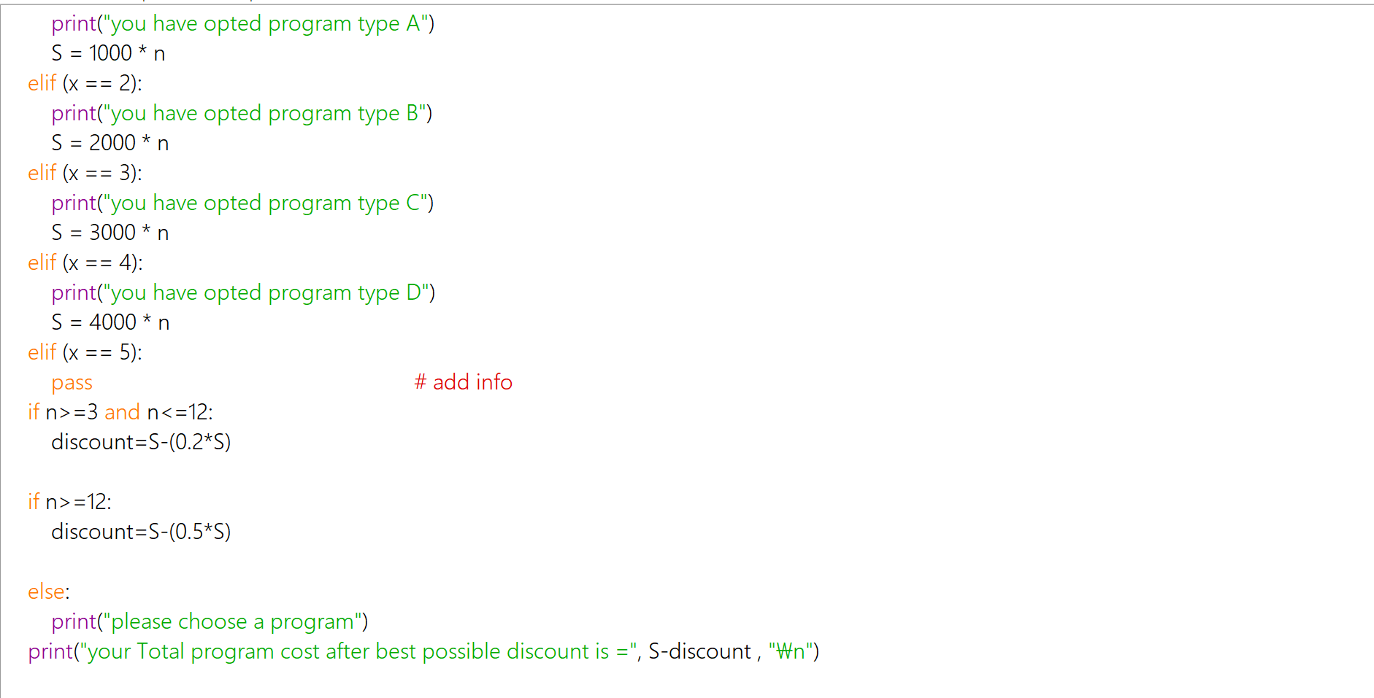

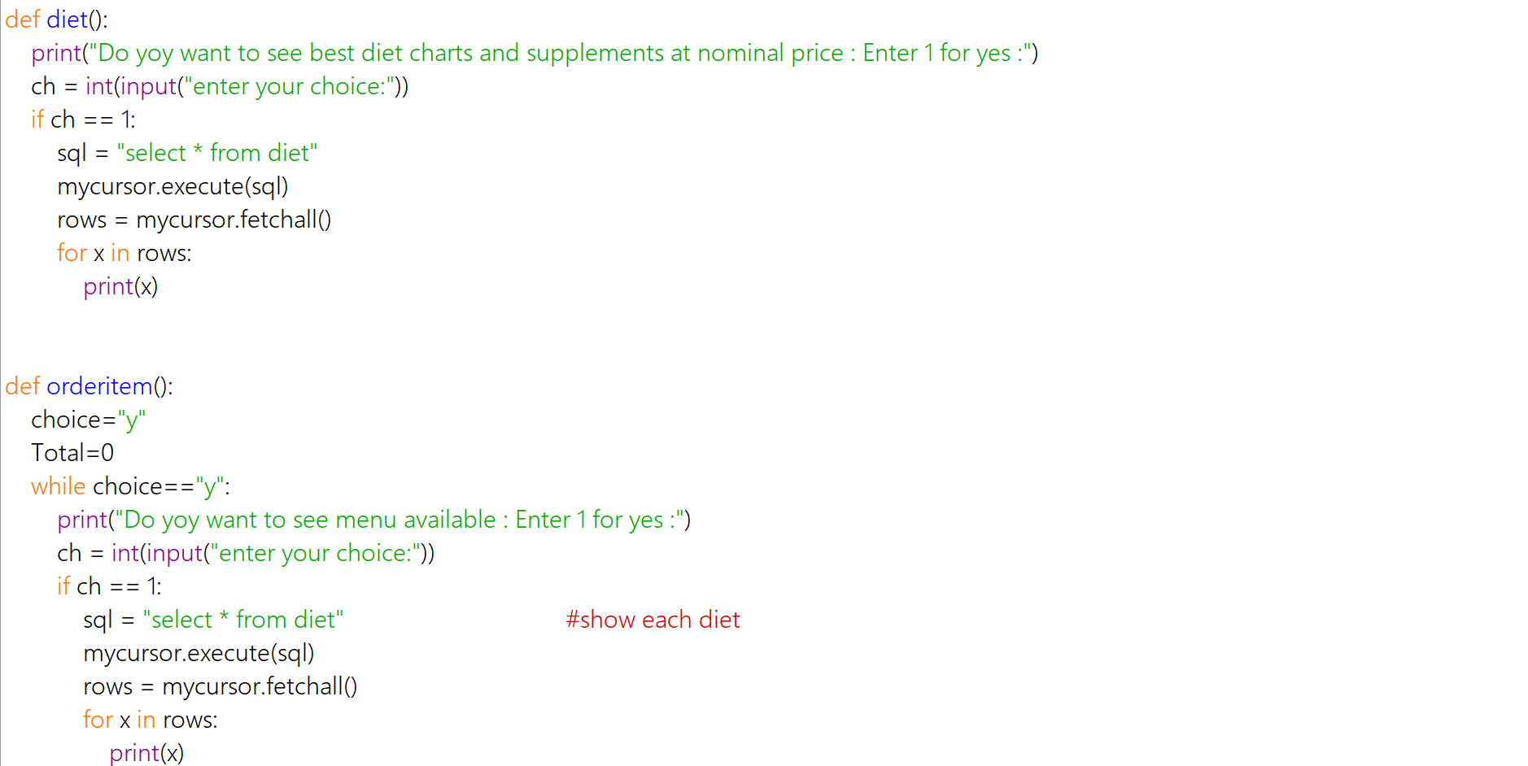

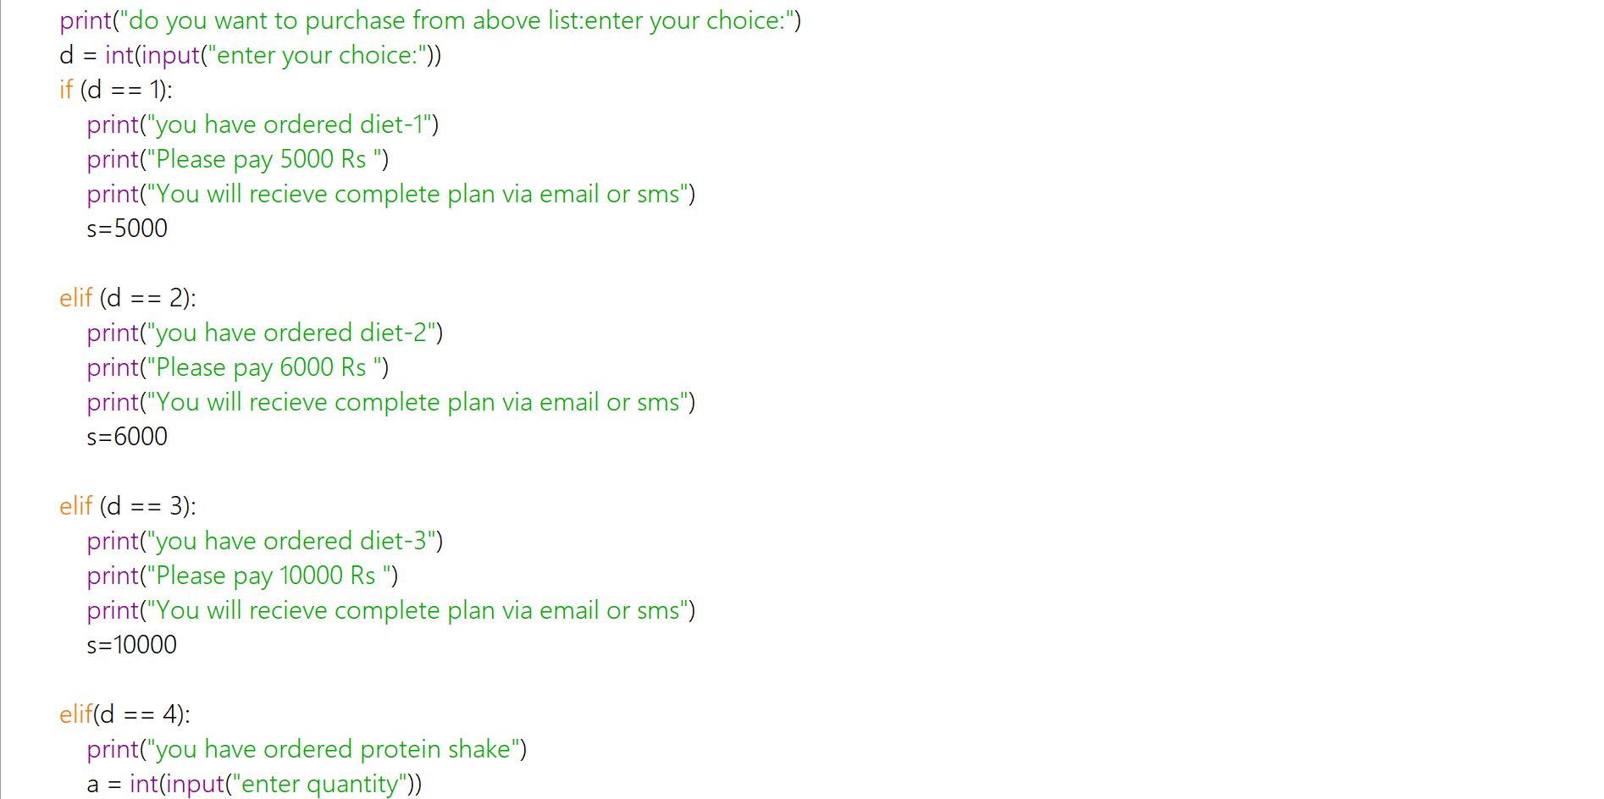

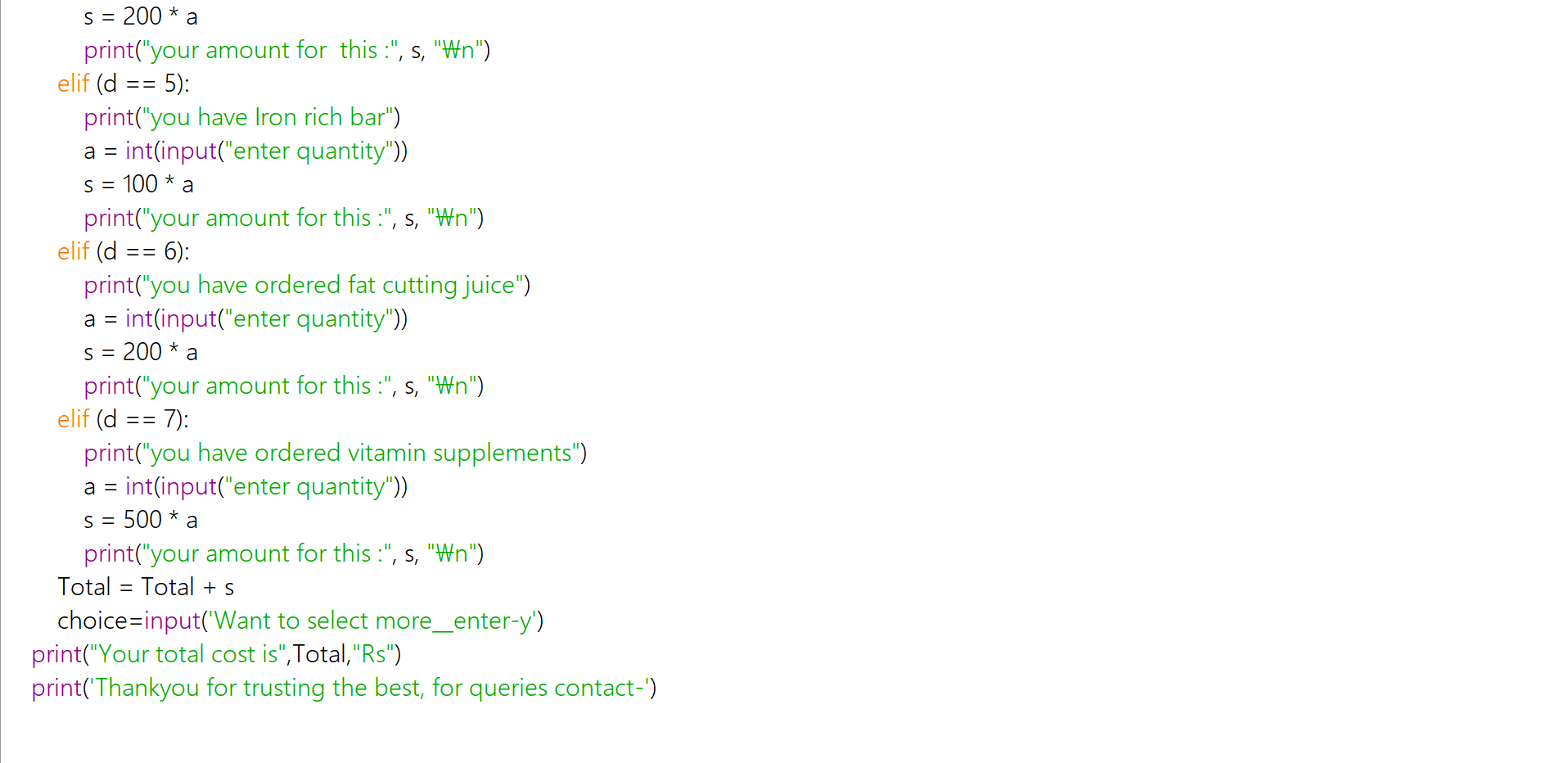

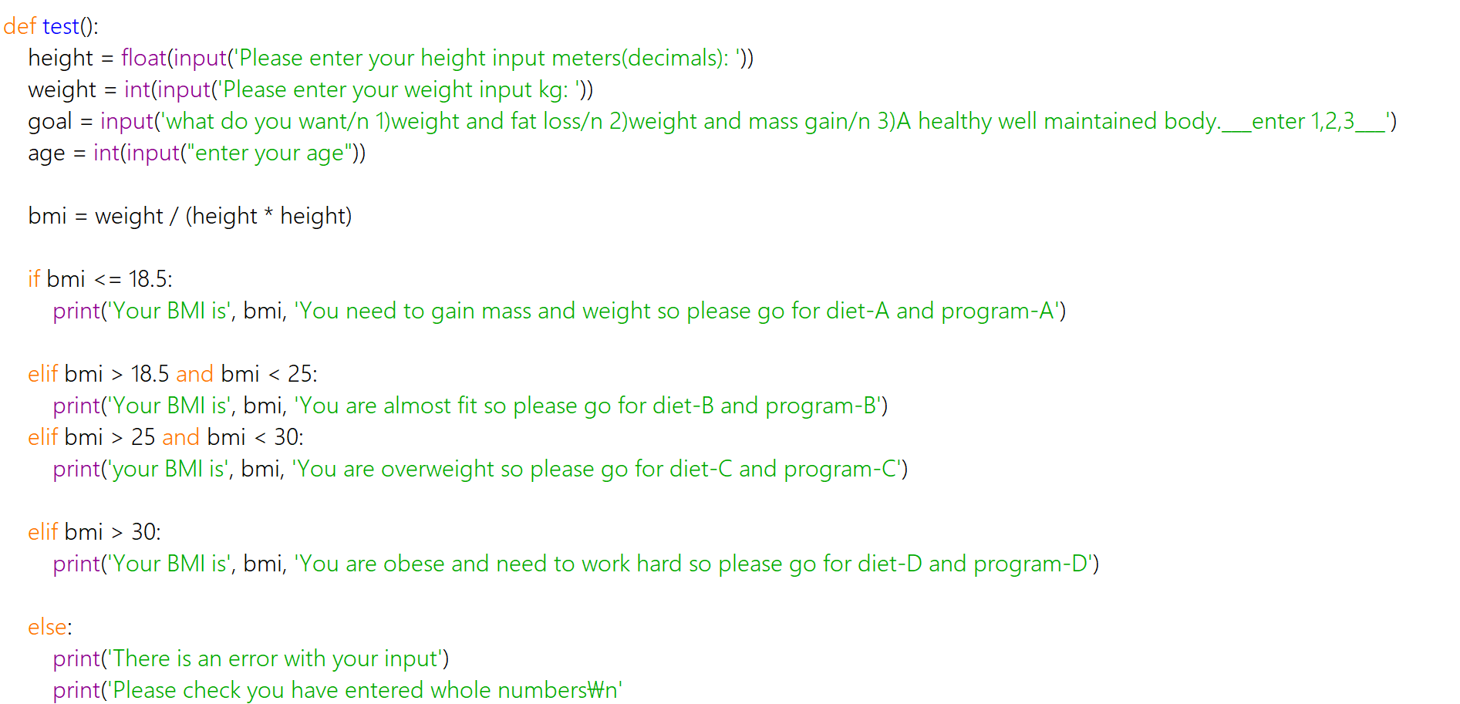

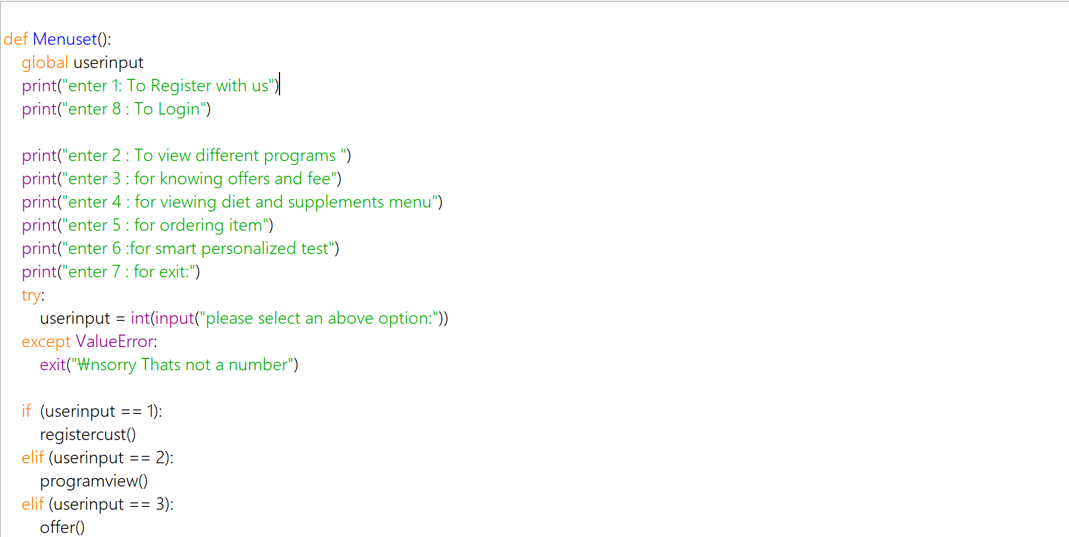

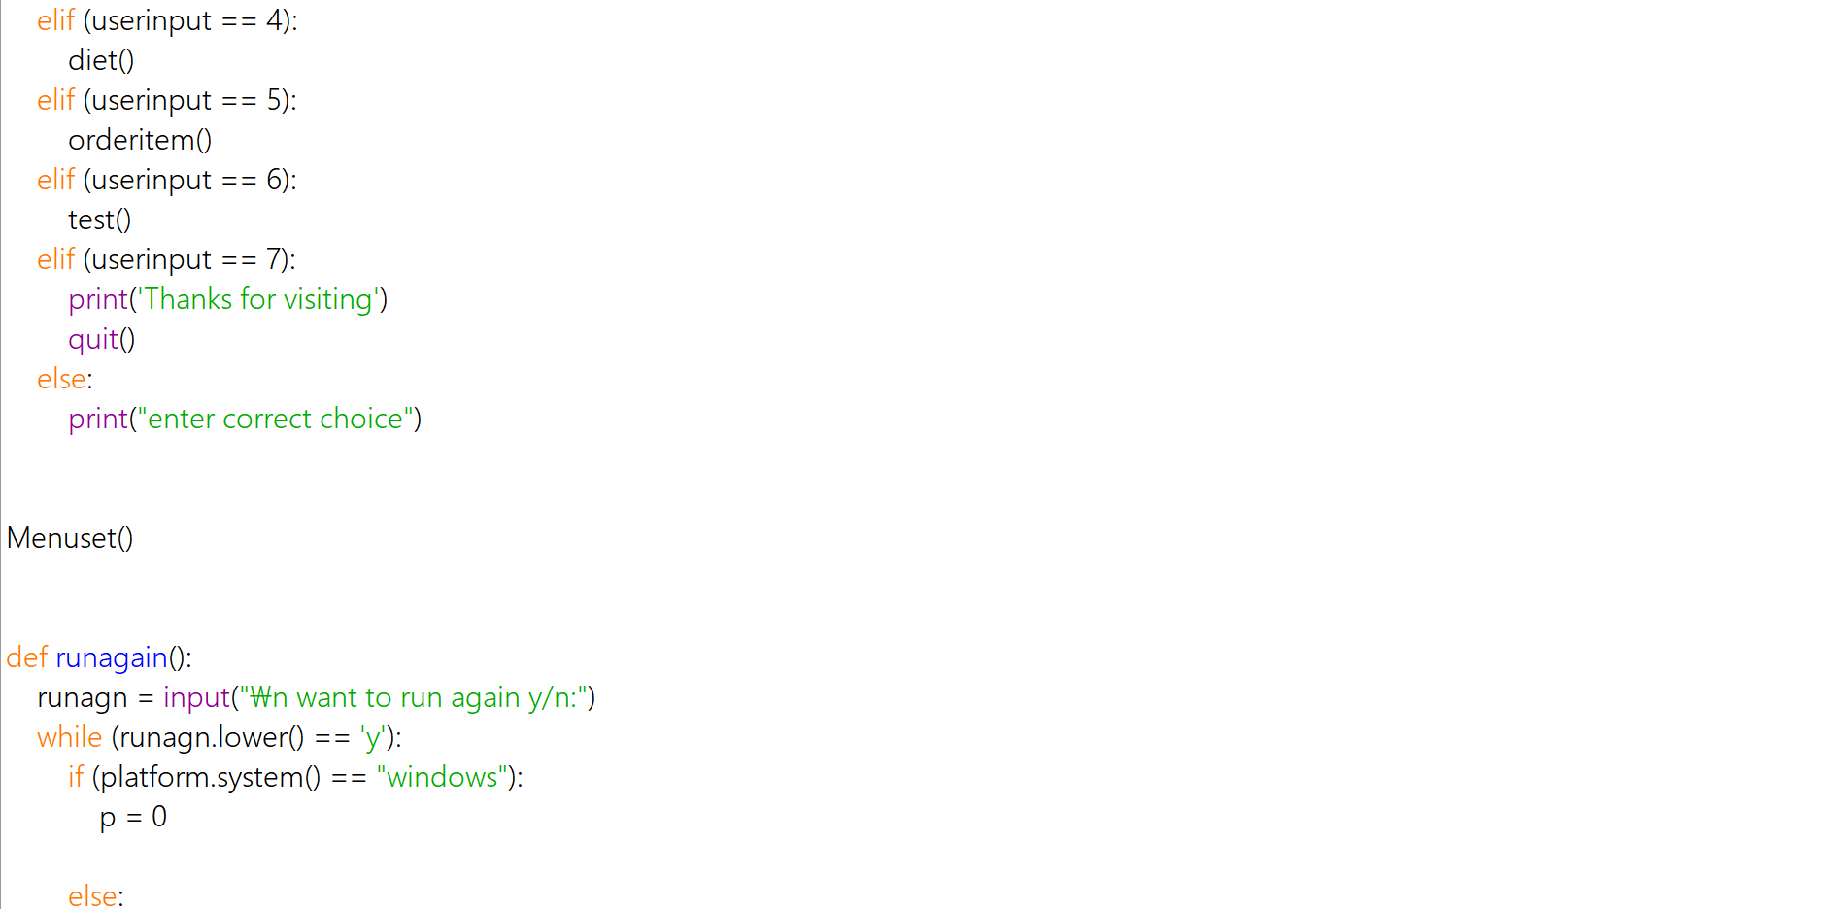

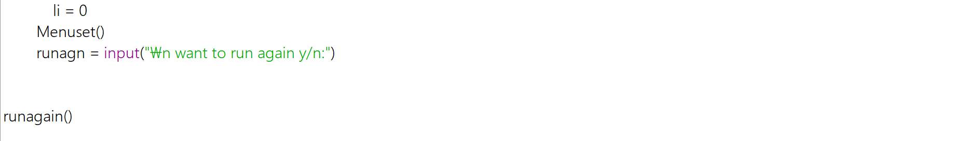

output

--------------------------

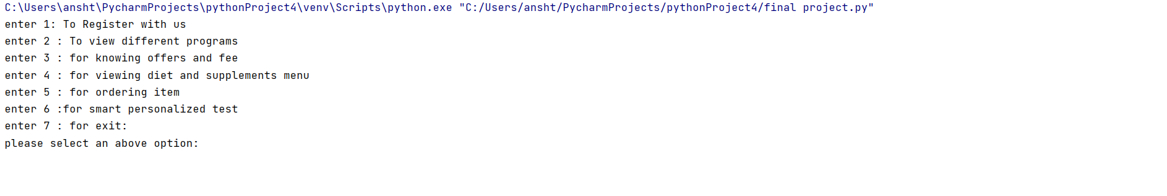

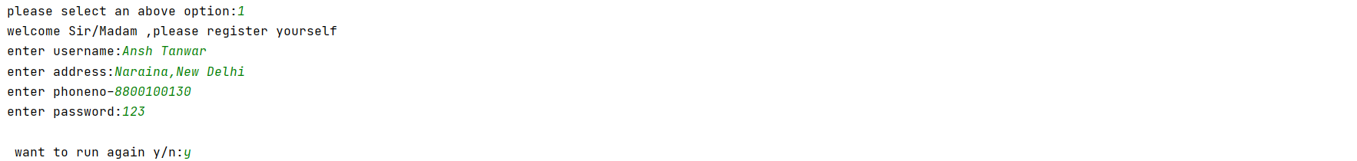

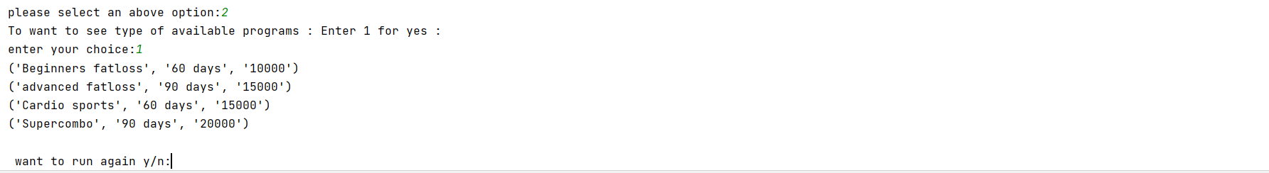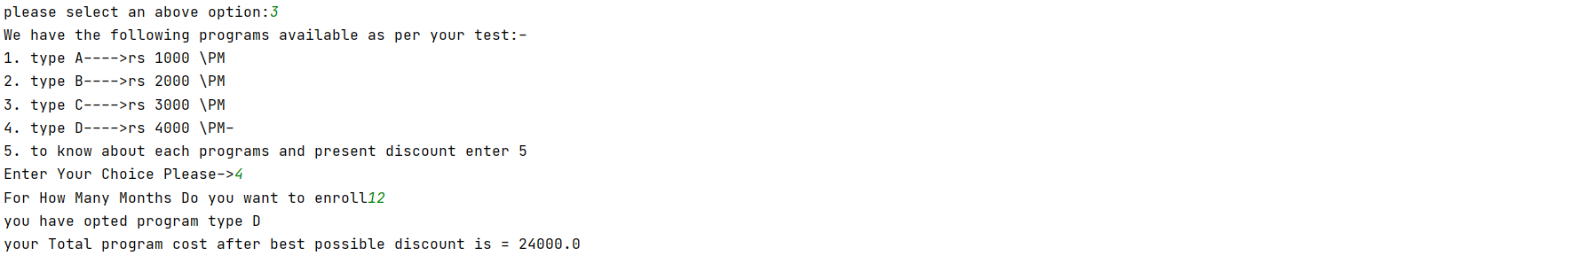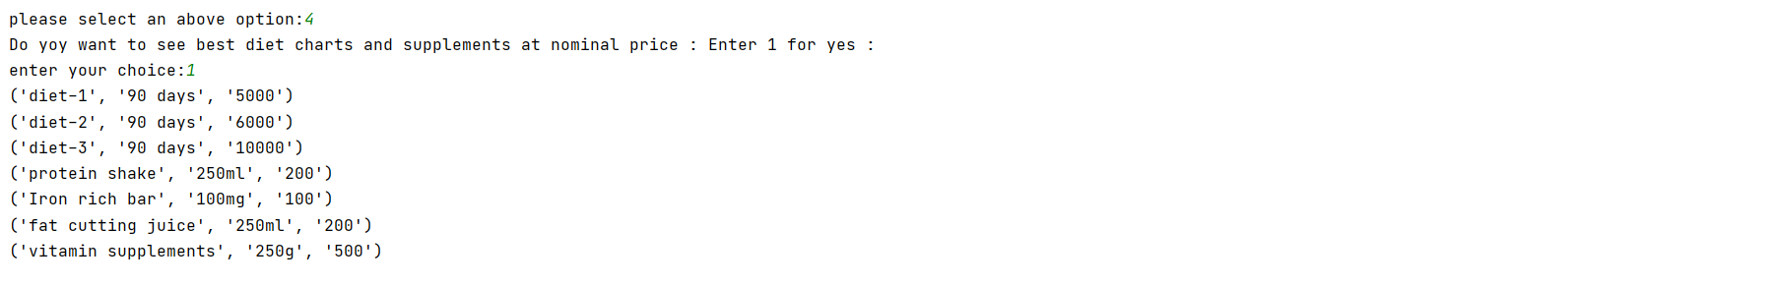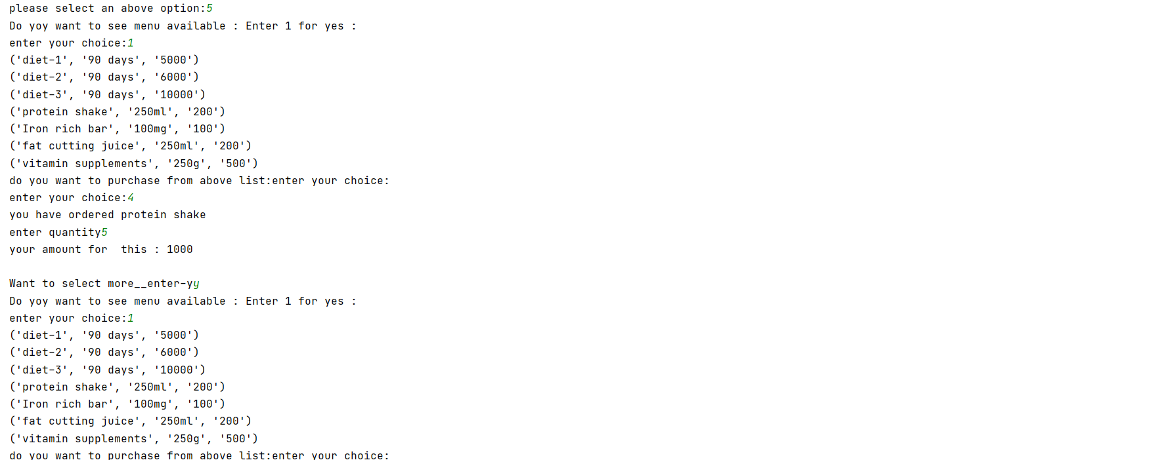

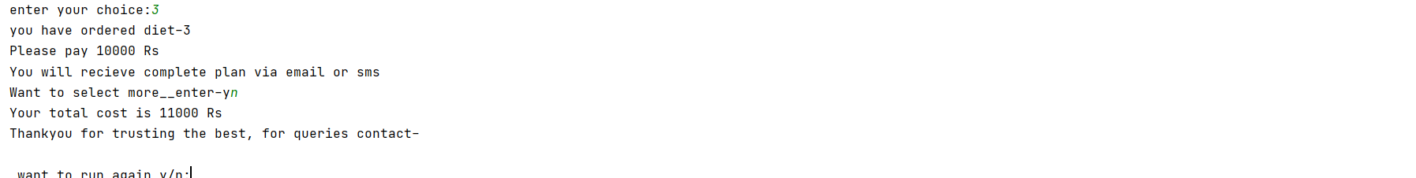

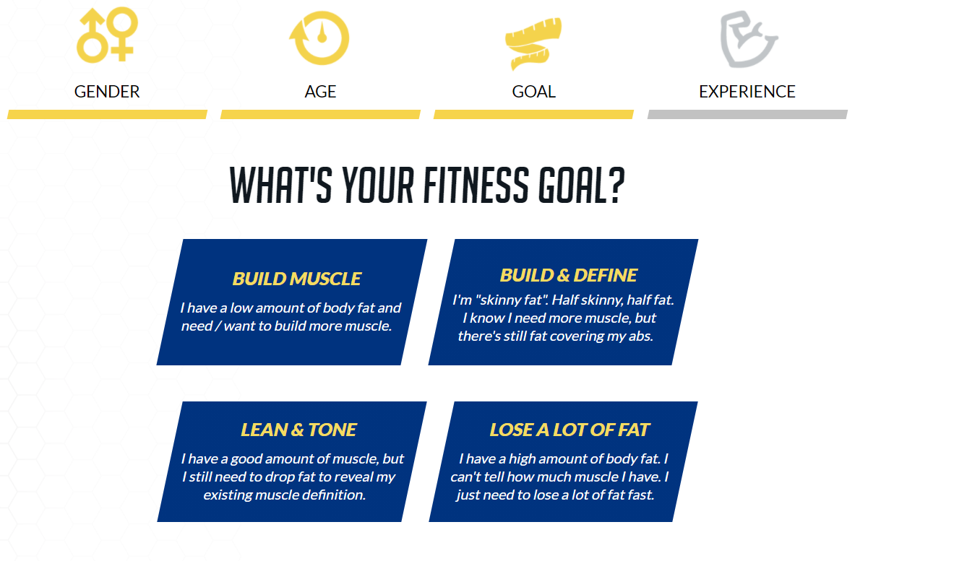

Bibliography

|  |  |
| --- | --- |
| >>> BOOKS | Computer science with Python by Sumita Arora |
| >>> websites | 1. [www.google.com](http://www.google.com)  2. <https://www.wikipedia.org/>  3.www.cbseportal.com |

 >>>

thankyou